CS 255 System Design

UML Diagrams

UML Use Case Diagram
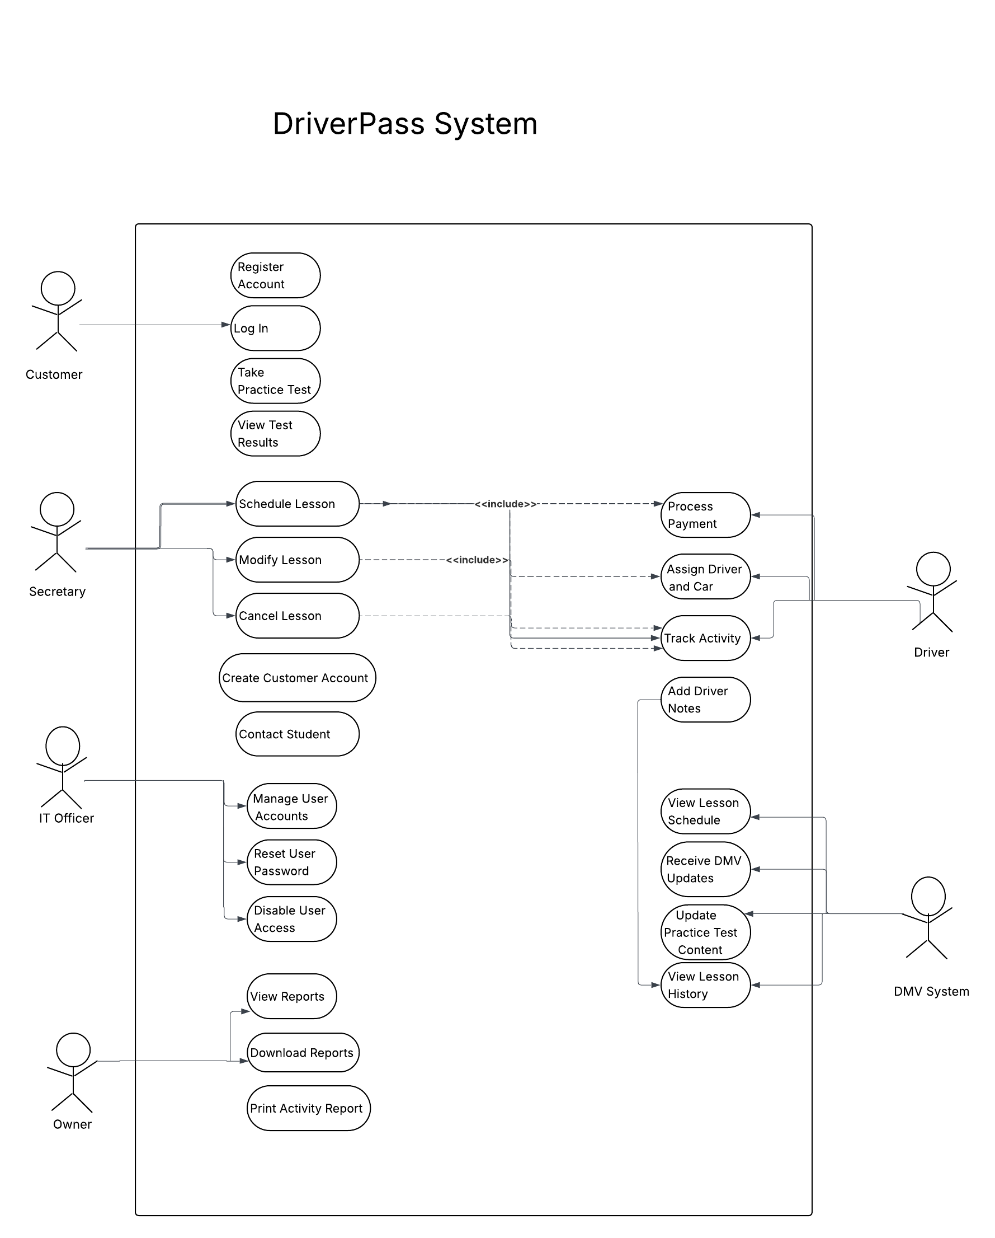
I created the UML use case diagram to show who uses the DriverPass system and what actions they can take. The diagram includes the customer, secretary, IT officer, owner, driver, and DMV system, since these are the main people or systems that interact with DriverPass. I added key functions like registering an account, logging in, scheduling, changing or canceling lessons, taking practice tests, viewing results, managing accounts, assigning drivers and vehicles, and generating reports. I picked these use cases because they match what the client asked for in the interview and highlight the most important services the system needs to provide. This diagram is important because it gives an overview of how the system will be used before looking at more detailed diagrams. It shows who is involved and what each role needs to do. I made sure to include both the customer side, like scheduling lessons and taking practice tests, and the business side, like managing accounts, reporting, and DMV updates. This helps make sure the system design meets the client’s needs for both operations and instruction.

UML Sequence Diagram
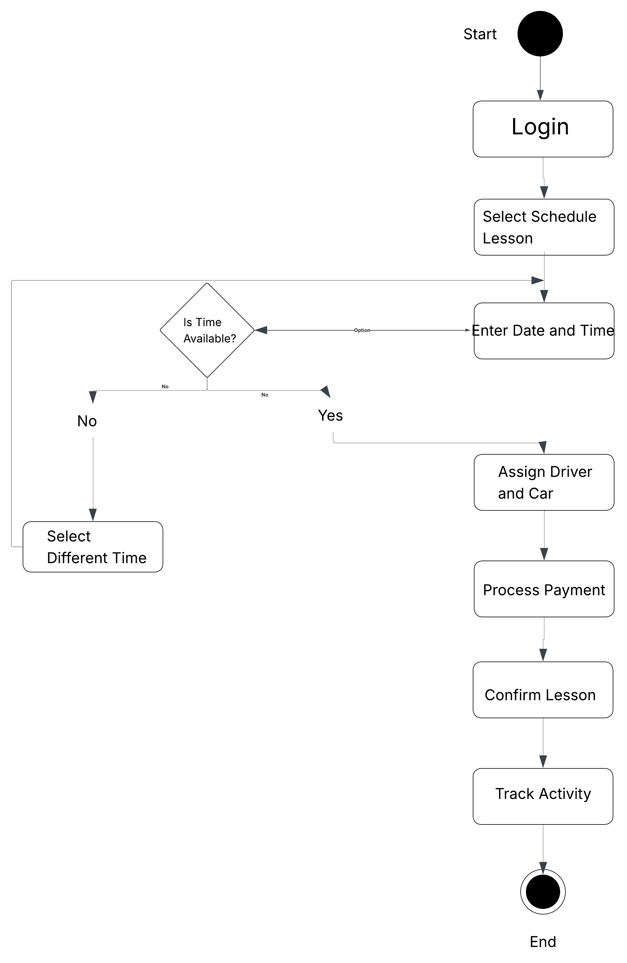
For the Schedule Lesson activity diagram I show the step by step process a customer would go through when booking a driving lesson. It begins with the customer logging into the system and selecting the option to schedule a lesson. The customer then enters a preferred date and time, which triggers the system to check availability. At this point, a decision is made if the selected time is not available, the system prompts the customer to choose a different time and repeat the process. If the time is available, the system continues by assigning a driver and vehicle, processing the payment, and confirming the lesson. The system also records or tracks the activity to keep an accurate history of the transaction. I made this diagram because scheduling lessons is a key part of the DriverPass system and includes several steps and choices. The diagram shows how the system manages both successful and unsuccessful booking attempts, making the process easy for users and meeting business needs. It also highlights important system actions like checking availability, handling payments, and tracking activities, all of which the client requested.

The Take Practice Test activity diagram shows the process a customer follows when using the online testing feature in the DriverPass system. The process begins when the customer logs in and selects a practice test. From there, the customer begins the test, answers the questions, and moves through the test until all questions are completed. Once the customer finishes, the test is submitted and the system scores it. After the scoring is complete, the customer is able to view the test results. This diagram helps show the flow of actions from the beginning of the test to the final results. I created this diagram because online practice testing is one of the main services DriverPass wants to provide to help students prepare for the DMV exam. It was important to include this use case because it represents the educational side of the system, while the lesson scheduling diagram represents the training side. This activity diagram shows how the system supports test taking, scoring, and result viewing in an easy to follow process, which helps make sure the design meets the client’s goal of improving student preparation.

UML Class Diagram

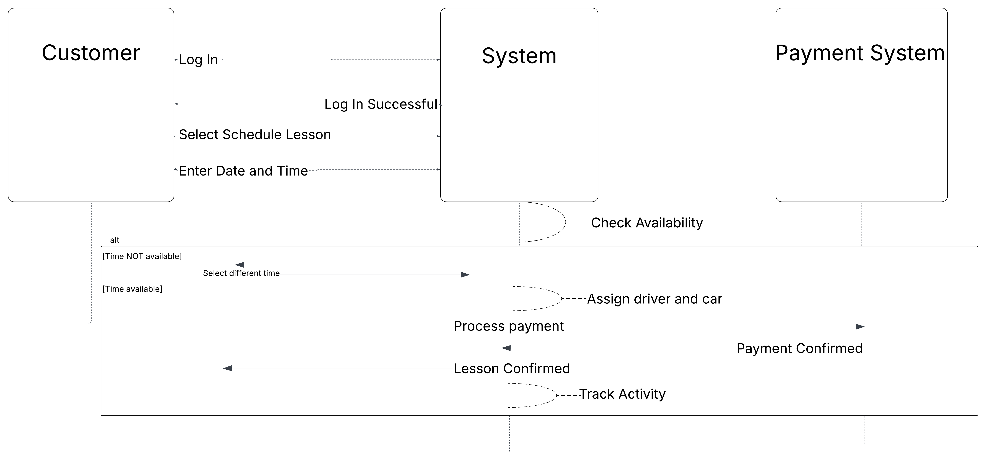
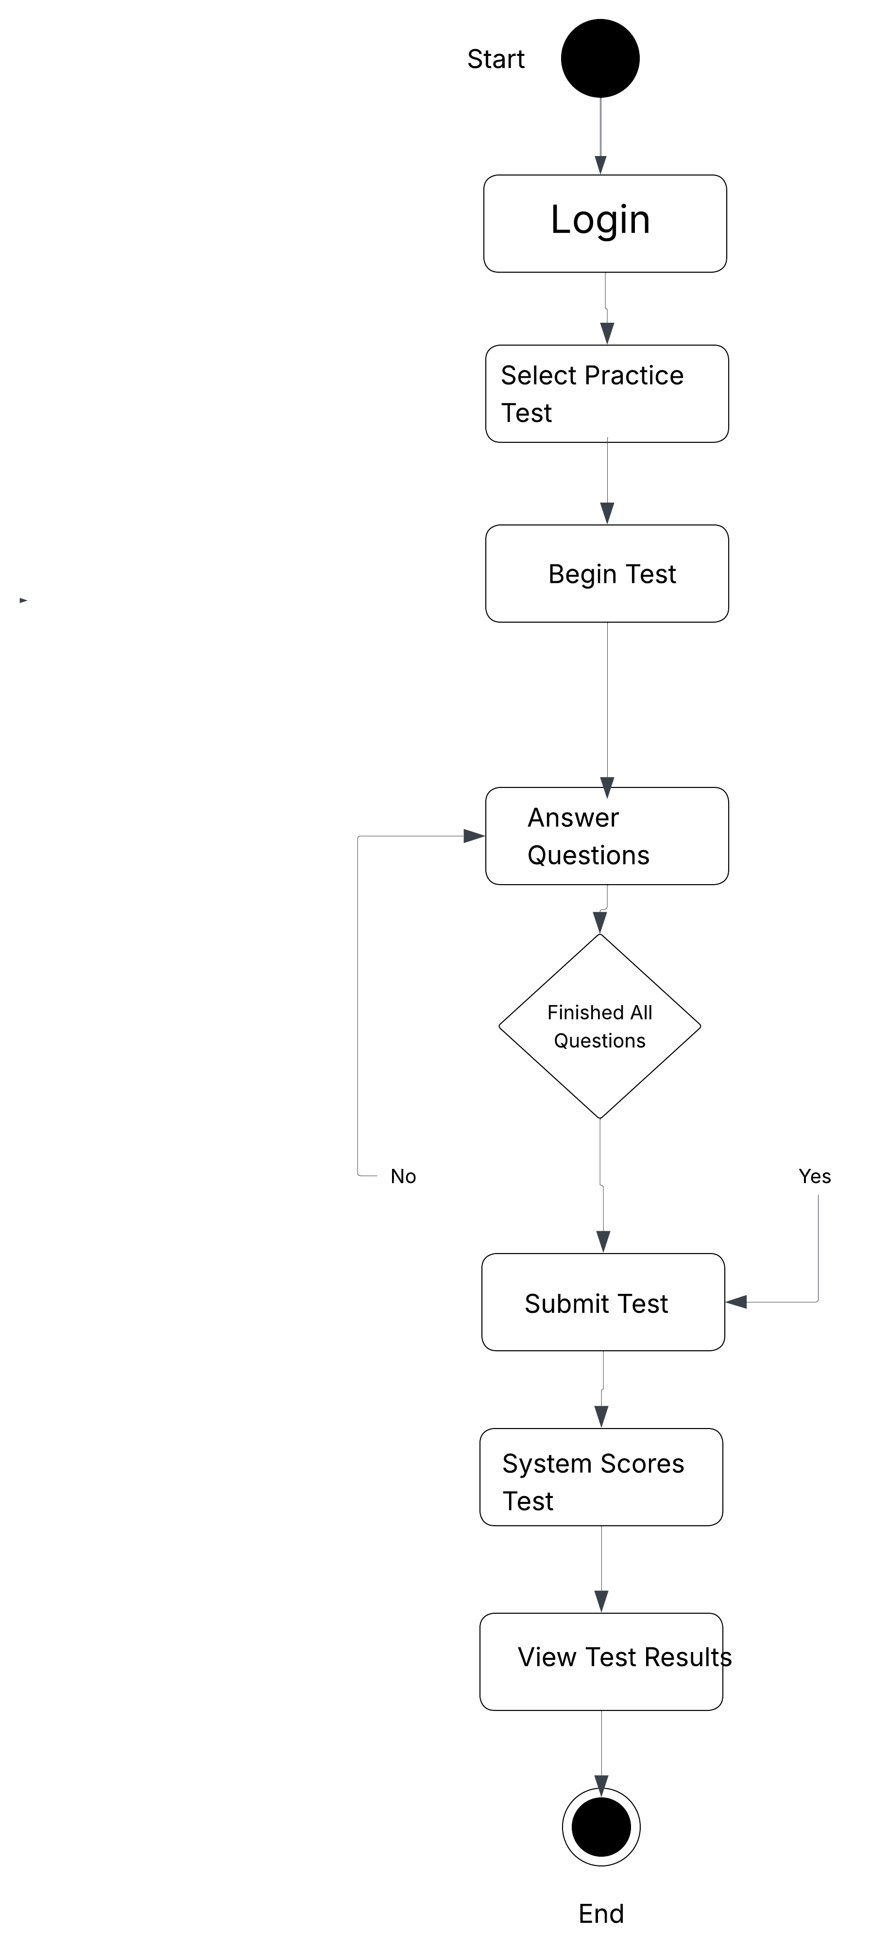
The Schedule Lesson sequence diagram explains how the system works when a customer wants to book a driving lesson. First, the customer logs in and chooses to schedule a lesson. After entering a preferred date and time, the system checks if that slot is available. If it is not, the system lets the customer know, and they can pick another time. If the slot is available, the system assigns a driver and a vehicle. Once a driver and vehicle are assigned, the system asks the payment system to process the payment. When the payment goes through, the payment system sends a confirmation back. The system then confirms the lesson with the customer and records the activity for tracking. I made this diagram to show how the customer, the system, and the payment service interact during scheduling. It helps make the flow of information and all the important steps, like payment and confirmation, easy to see.

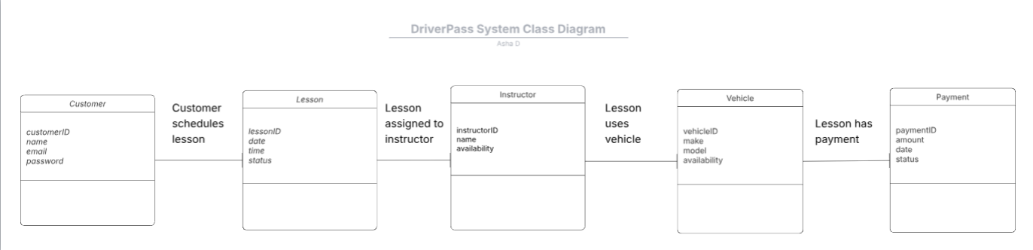

The DriverPass system class diagram shows the main classes in the system and how they connect. I included Customer, Lesson, Instructor, Vehicle, and Payment because these are the key parts of DriverPass. The Customer class holds basic user information for account access and scheduling. The Lesson class stands for each driving lesson and includes details like date, time, and status. Instructor and Vehicle are linked to Lesson since every lesson needs a driver and a car. Payment is also included because it is part of scheduling and must be linked to the lesson. I made this diagram to show how the main parts of the system are connected. It helps explain what information the system needs to keep and how everything works together. For example, a customer schedules a lesson, which is assigned to an instructor and uses a vehicle, and each lesson has a payment linked to it. This class diagram supports the other UML diagrams by showing the data structure behind the system’s processes and interactions.

Technical Requirements

The DriverPass system should be a web-based application, allowing customers, instructors, office staff, and administrators to use it from any location on a computer, tablet, or smartphone. Since the client wants the system to be available online and work on multiple devices, it should run in a standard web browser without needing special software. The system should include secure logins, online scheduling, practice tests, lesson tracking, reporting, and payment processing. Using a cloud-based setup is ideal because it makes remote access, data storage, backups, and maintenance easier. The hardware requirements for this system would include computers for office employees, instructors, and administrators, along with mobile-compatible access for customers who want to use the system on their phones or tablets. On the business side, the company would also need reliable internet access, secure servers or cloud-hosted server resources, and printer access for reports or activity records. Since DriverPass wants to store customer records, lesson schedules, practice test data, and payment information, the system would need a database server or cloud database to manage that information efficiently and securely. The software requirements would include a web server, a database management system, and secure browser-based access. The system should support role-based access so different users only see the information and functions related to their responsibilities. For example, customers should be able to register, log in, schedule lessons, and view test results, while administrators should be able to manage accounts, disable access, generate reports, and monitor activity. The system should also include integration with a payment processing service and the ability to receive updated DMV-related information so practice tests and training content stay current. The system infrastructure should emphasize security, availability, and reliability. Since DriverPass handles personal data, scheduling details, and payment information, the system should use encrypted connections and protected user authentication. It should also maintain activity tracking so the company can see who created, changed, or canceled reservations. To reduce downtime and support multiple users at one time, the system should be hosted in a stable cloud environment with regular backups and ongoing maintenance. Overall, the technical requirements should support a secure, scalable, and easy-to-use system that matches DriverPass’s business needs and future growth.

